Generating ONMS Soundscape Inventory Reports

Purpose of reports
Reporting on ocean sound conditions from the ONMS long-term monitoring sites helps to ensure the information is available for sanctuaries. These updated web-based reports include the most recent results for soundscape conditions and best available ocean sound indicators. The intention of the reports is to:
- provide ONMS-sound team with updates on available data and general soundscape conditions
- provide the ONMS-sound team with a communication tool to show status and trends of soundscape conditions and ocean sound indicators
- provide an overview of ocean sound indicators available for sanctuary condition tracking

Guiding principles
- Use publicly available data from open data repositories (e.g. NCEI-GCP)
- Transparent code development
- Leverage existing open-source data processing and visualization tools (e.g. PAMverse)
- Concise and clear explanations of graphics
- Collaborative development with ONMS sound team, regional coordinators, and Sanctuary Watch

Important documents
- ONMSSound_IndicatorCategories.xlsx (edited in google sheets)
- PAM-SI soundscape technical documentation

Terminology
- Soundscape Metrics | raw audio data calibrated to 1-min power-spectral densities in hybrid millidecade frequency bands saved in NCEI netCDF file format, often referred to as sound levels dB re 1 𝜇Pa²/Hz
- Soundscape Labels | soundscape metrics labeled with known acoustic source(s) present. A variety of source detection methods (e.g. marine mammal calls) and non-acoustic data sources are combined with the soundscape metrics (e.g. wind speed, vessel traffic, biological survey). Soundscape labels divide the metrics into different categories to understand how sound levels vary and percent of the time soundscapes are within different categories.
- Soundscape Scenes | a user defined combination of the types of sources present, using the soundscape labels. For example, a biological soundscape scene is only when any biological sound is present.
- Soundscape Condition | tracking how sound levels change in different frequencies using the soundscape metrics. Soundscapes vary across years, seasons, and within a day. Differences are driven by shifts in wind and weather patterns, migration and behavior of animals, and patterns in human activities. Seasonal and annual percentiles of all the data are used to see how daily values fall within ranges for a given monitoring location.
- Ocean Sound Indicators | ocean resource-management relevant metrics derived from long-term monitoring of ocean sound to track status and trends conditions. These indicators track habitat, species, human-use, and management activities. There are many analytical methods used to generate ocean sound indicators. In some locations sound frequencies are dominated by a specific source and we can use this frequency (e.g. 125 Hz for vessel noise) to track conditions. Other methods detect specific sources of interest. For example, the National Marine Fisheries Service (NMFS) maintains analysis of the presence of marine mammals from ocean sound monitoring data.
- Background Soundscape | an estimate of sound levels when no detections are present using an unsupervised separation (e.g. RRPCA) of soundscape metrics into background and transient conditions based on decomposition of the soundscape metrics within a defined frequency band
- Soundscape Features | unsupervised separation of metrics into salient features and unique spectral features (e.g. clustering), dependent on settings for the automated/unsupervised learning and can be defined within sites, seasons, scenes, or management scenarios.

Project structure
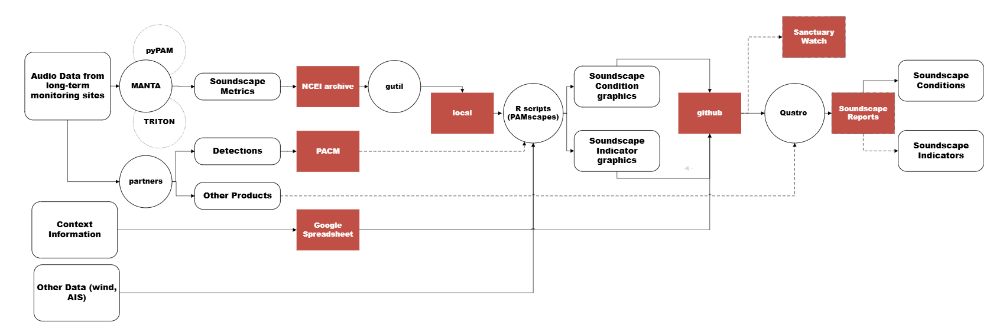
created with Microsoft Visio

Audio data from long-term monitoring sites
Overview of current steps (video- demonstrating adding a site)
- Creating standard sound level – use available data processing software to create a standardize soundscape metrics with quality information (region-led, PAM-SI guidelines)
- Package and archive data at NCEI (region-led); NCEI upload to GCP
- Download data to local drive for processing- organize by site name (e.g. hi01), option to pull data from repositories hosted by partners (e.g. AWS, google drive, NMFS-cloud)
- Run R-scripts to process data (see Appendix: generating graphics for details and videos)
- Refresh Soundscape website to see updated graphics
Recommended updates/changes

Context information
Explanation of current steps (video)
- The ONMS Sound team maintains and updates a google sheet with important information about the long-term monitoring sites.
- Analysis downloads
Recommended updates/changes
- Update code to be able to format the text as

Other data

APPENDIX: GENERATING GRAPHICS
- Clone repository to your local computer: https://github.com/CI-CMG/SoundscapesWebsite
- Generate updated gantt chart and maps using summary_ONMS-GCP.R (video-done)
  - Make sure you have all the libraries installed to run the code
  - Change default output directories to your local machine ("F:\\CODE\\GitHub\\SoundscapesWebsite\\content\\resources")
  - Code runs through each site on GCP to gather and combine information from the metadata files, then adds some information in the ONMS context spreadsheet (console shows where you are in the process)
  - Code saves a 2 summary file - one with all the sites, one truncated to just the long-term monitoring sites (since we are plotting in this script, option to not save this file)
  - 3 plots are generated and saved to website content/resources directory
    - Gantt with all ONMS sites (goes to report home page)
    - Gantt with only ONMS long-term monitoring sites
    - Map with total days of recordings at each site
    - Data files to products/onms directory
- Download soundscape metrics from NCEI- Google Cloud Platform
  - Use guidance provided by NCEI (link)
  - Set up directories on your local machine. Recommendation to create directory for each site with lower-case letters (e.g. F:/ONMS/sb01) and make sure you have enough space to download (you can delete once processing is complete, if needed)
  - ONMS data: Use command prompt to download the data: e.g. gsutil -m rsync -r gs://noaa-passive-bioacoustic/onms/products/sound_level_metrics/sb01 F:/ONMS/sb01 (NOTE: change highlighted to site you want to download and update your local directory)
  - SanctSound data: downloaded to a local directory- these are the files you want SanctSound_HI03_04_TOL_1h.csv. You can use the g-utility to download from GCP: navigate to specific file and download and move to correct directory F:/ONMS/hi03/SanctSound
  - Check to make sure data downloaded properly before proceeding
- Generate comparison graphics using compare_SanctSound-month (video- done)
  - Need to have all data from SanctSound downloaded to a local directory- these are the files you want SanctSound_HI03_04_TOL_1h.csv. You can use the g-utility to download from GCP gsutil -m cp -r \ gs://noaa-passive-bioacoustic/sanctsound/products/sound_level_metrics/hi03/sanctsound_hi03_04_tol_1h F:/ONMS/hi03/SanctSound
  - Set your directories correctly at the beginning of the code
  - The code is set up to run for specific site types- coastal-shallow sites only and only data in 2019, so not all sites will have data. You can modify the code if you want to compare specific sites/years... find_ONMSdata-GCP.R was created to do this (you will need to modify to find what you need)
  - Outputs a graphic for each site that meets the criteria and save in your GitHub\\SoundscapesWebsite\\content\\resources directory, so it shows up on the website when you click “How does my sanctuary compare?” button

